**HOME PAGE:**

**1.**

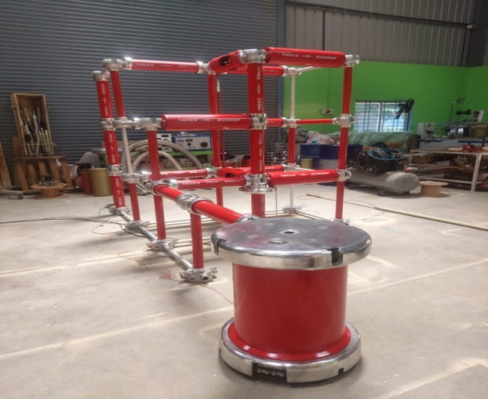 **@ CUSTOMIZED EQUIPMENT FOR TESTING, MEASURING**

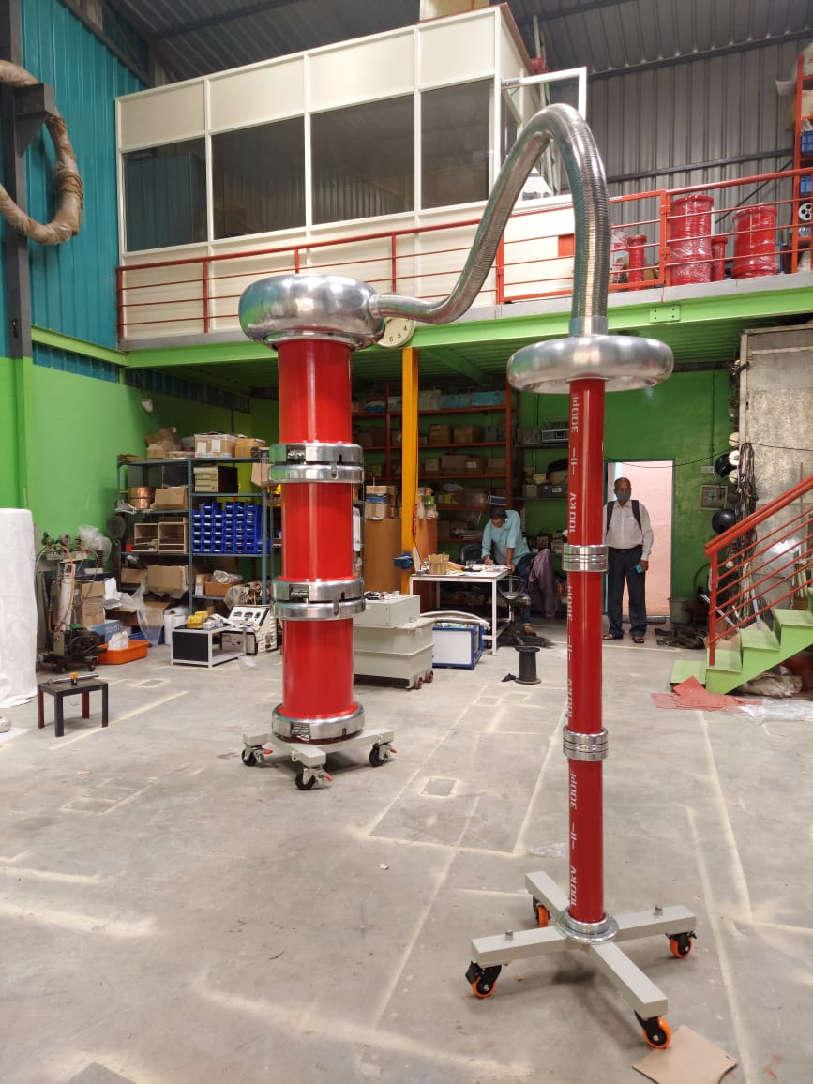 **AND PROTECTION IN THE FIELD OF HIGH VOLTAGE**

**Consultancy for field study, Root Cause Analysis of High Voltage**

**Equipment &Systems, Designers, Developers and Manufacturers**

**of Customised Equipment in the field of High Voltage.**   **CAPTIONS HERE** 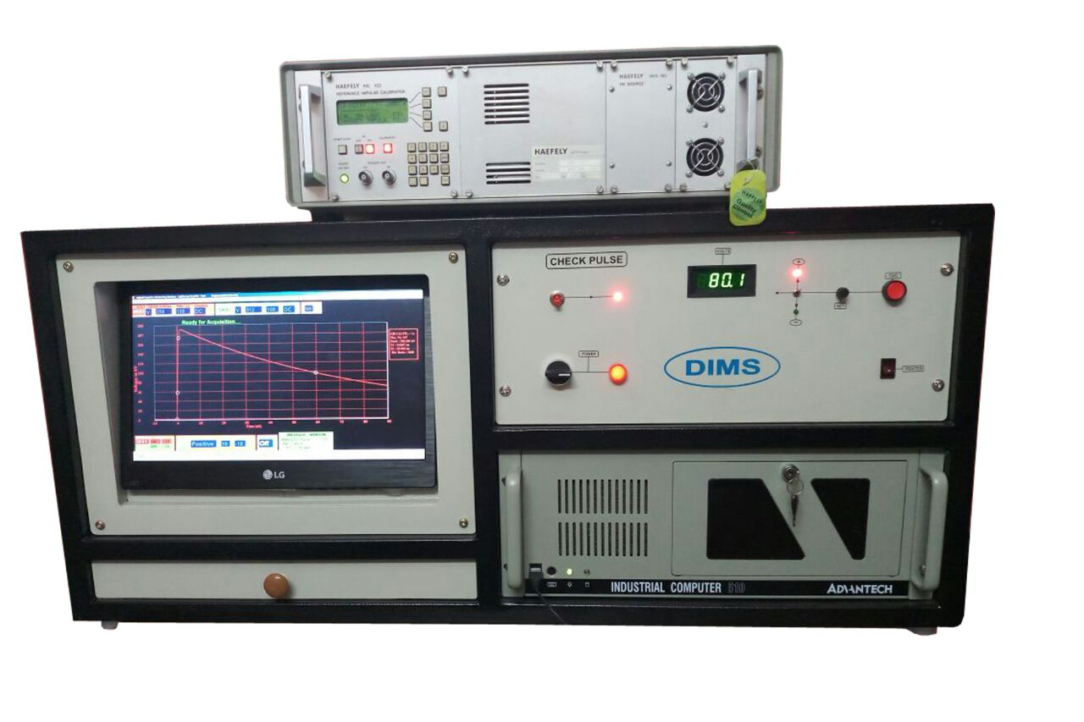 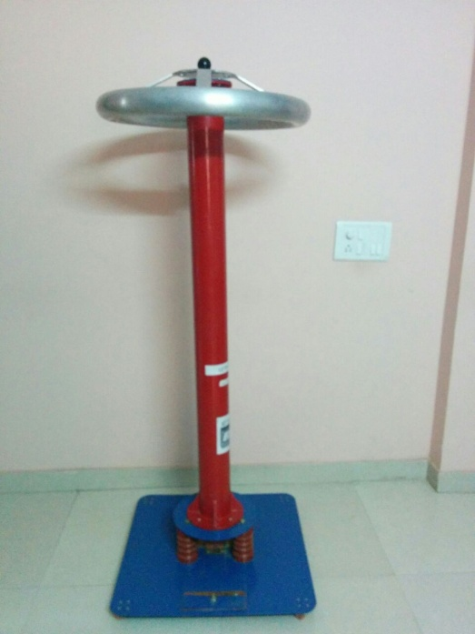

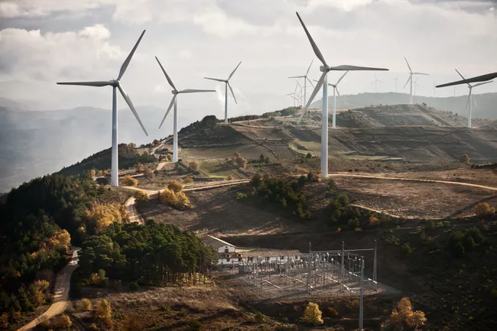

**2. FIELD STUDY AND RECOMMENDATIONS FOR 100% GRID STABILITY**

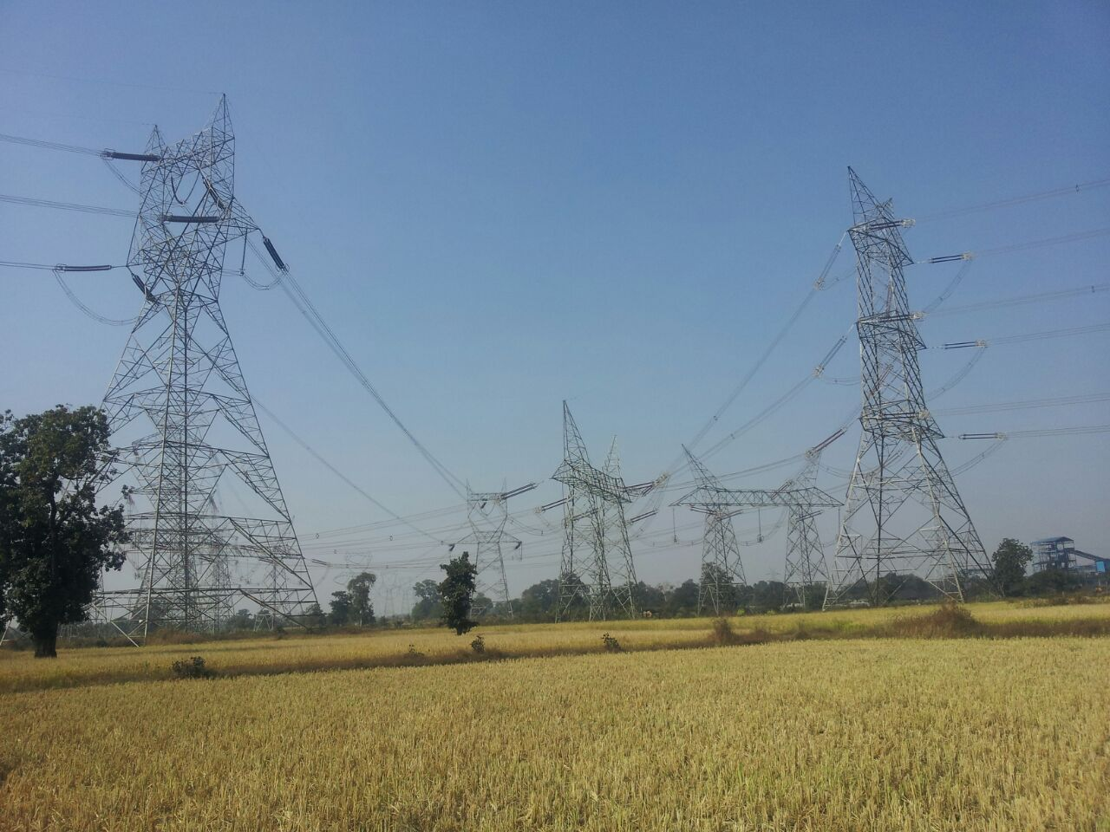 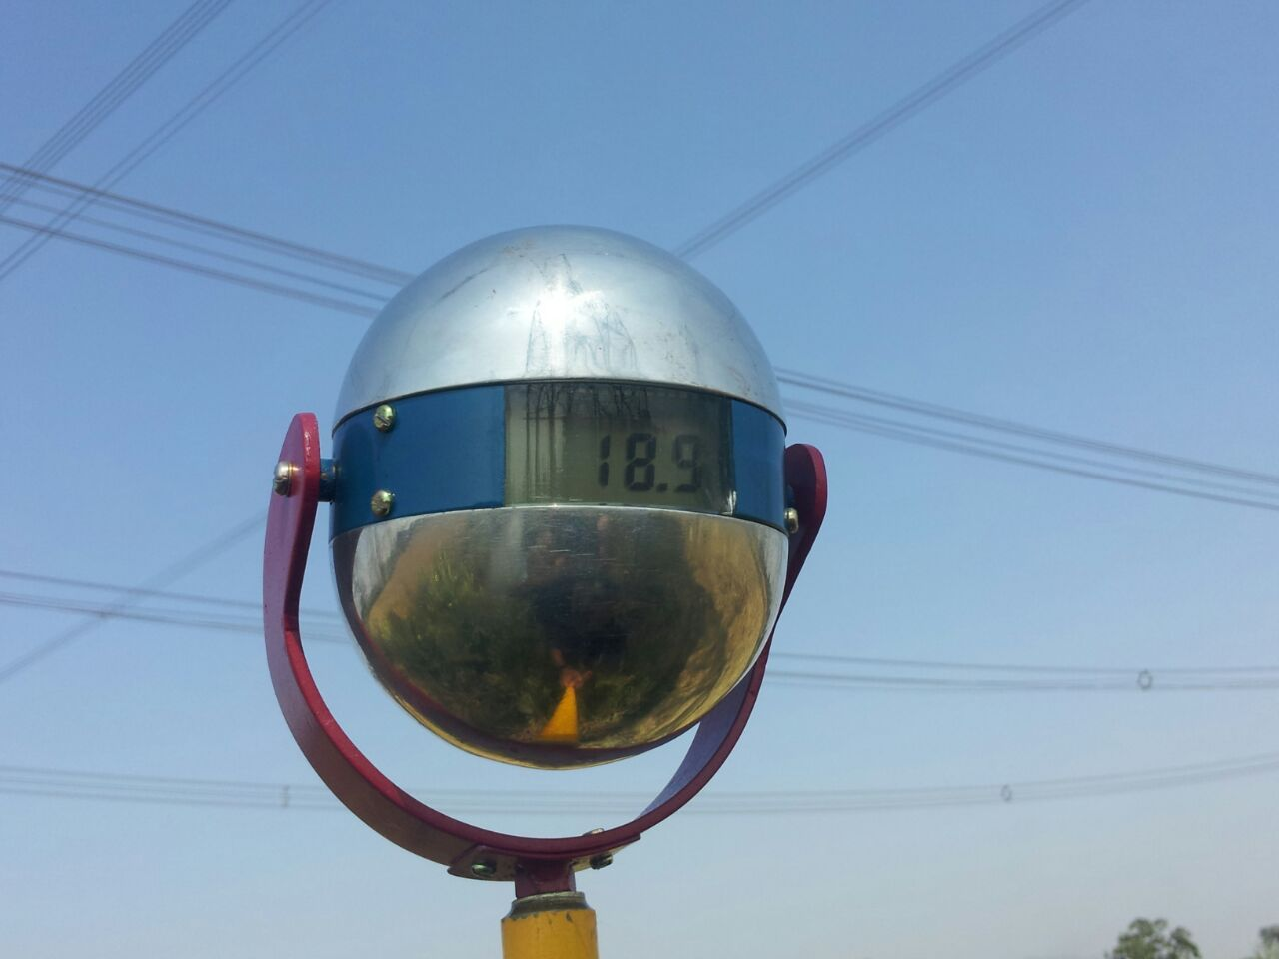 **@AC Electric & Magnetic field measurement**

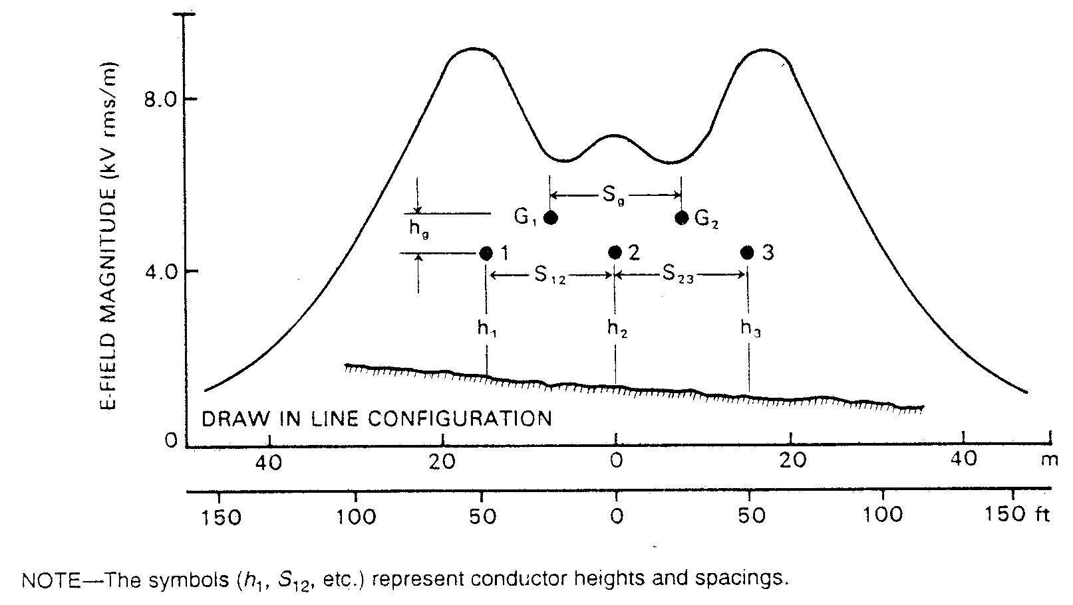 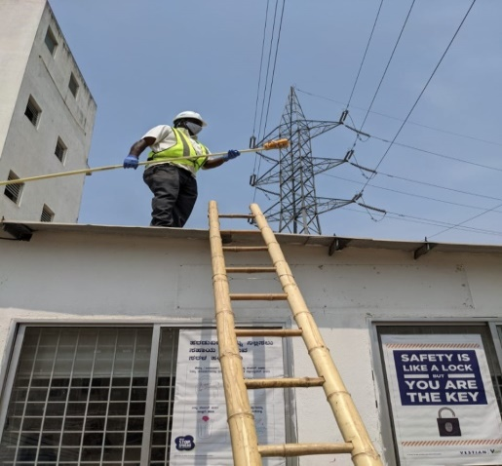 **under 765kV AC transmission line**

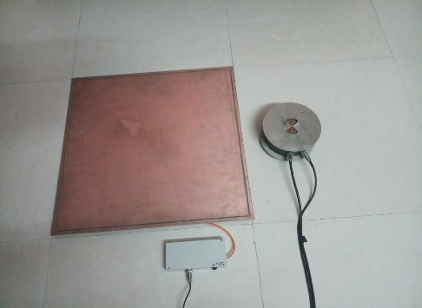 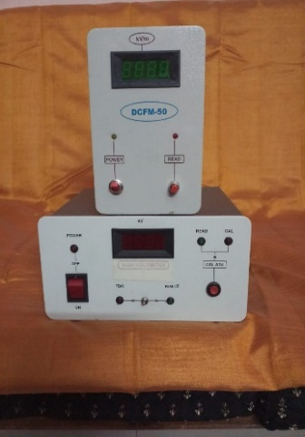 **@ DC Field and Ionic Current meter**

**3. Third party inspection of heat run test on power Transformer**

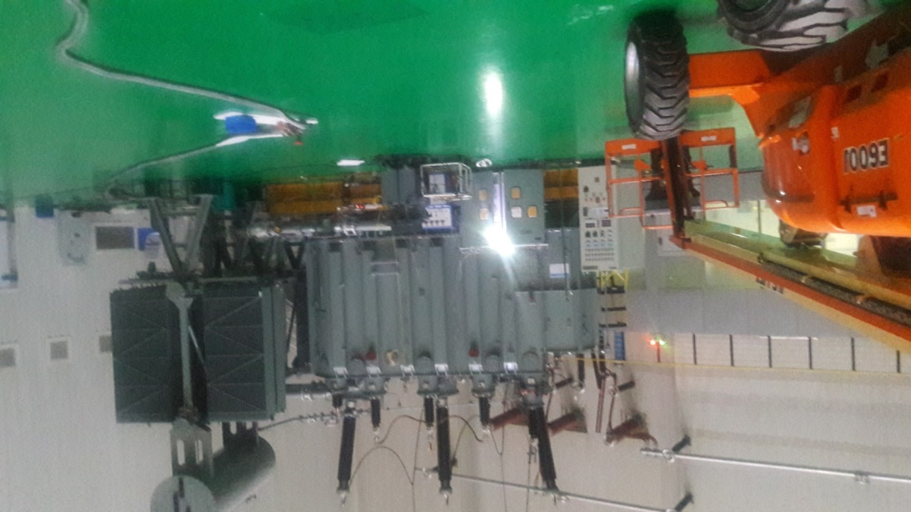

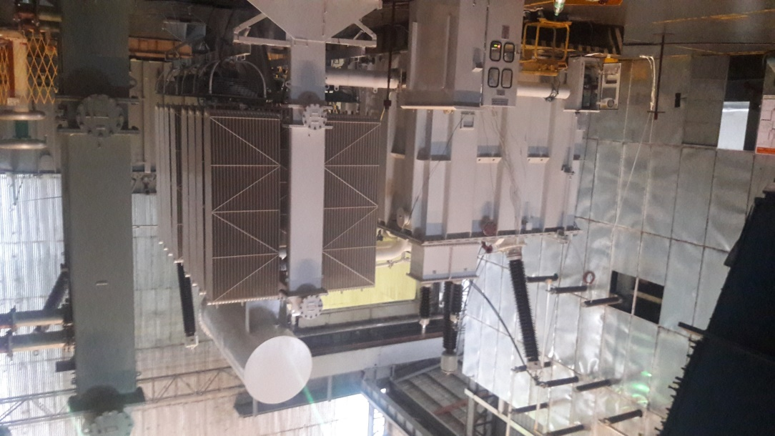

**@ GIS System under Heat run test**

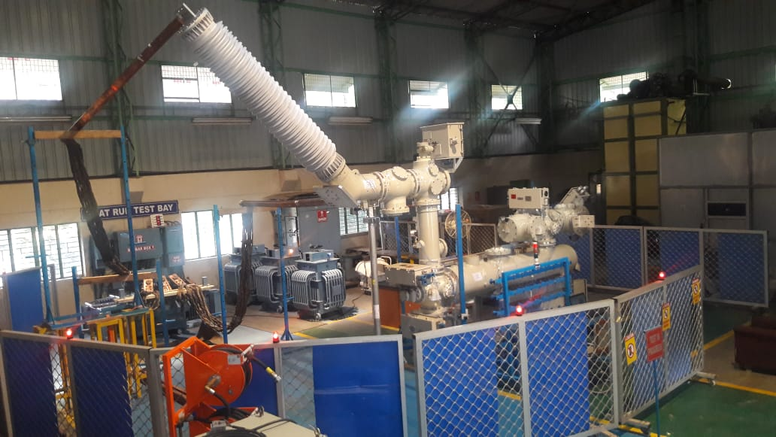 **@ 220kV GIS System under Temperature rise test**

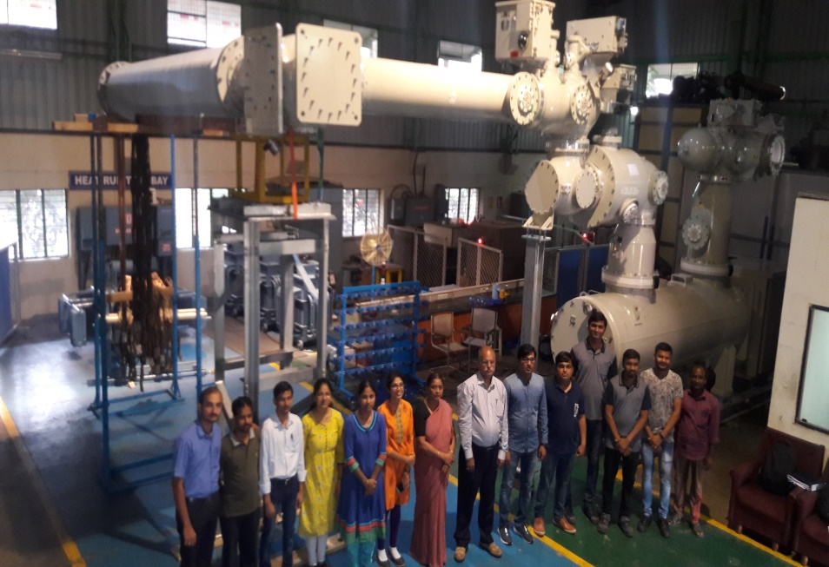 **@ 400kV GIS System under Temperature rise test**

**5. Customised equipment**

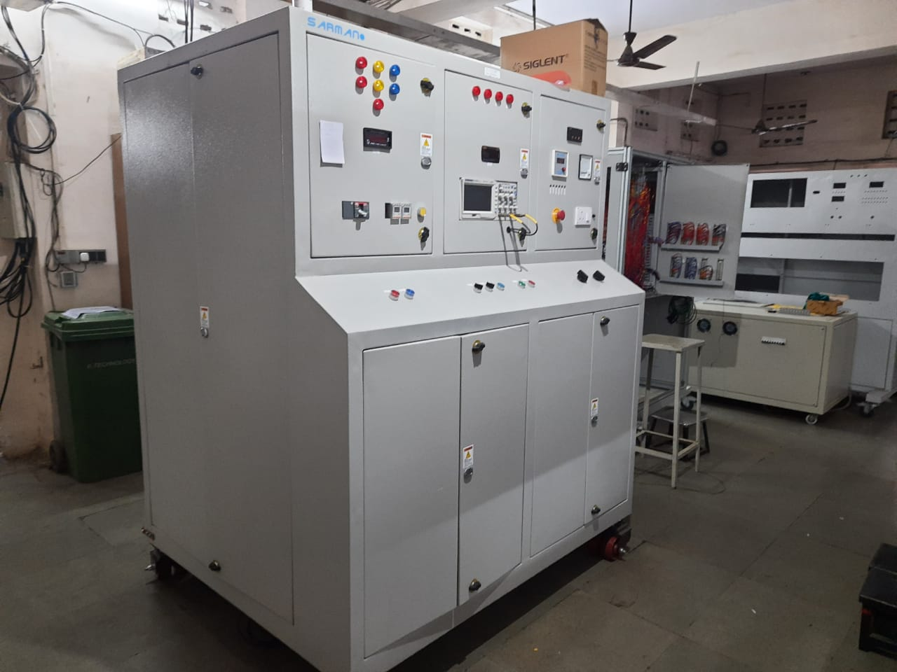 **@ Short time high current source (1mS to 10mS and 1kA to 8kA)**

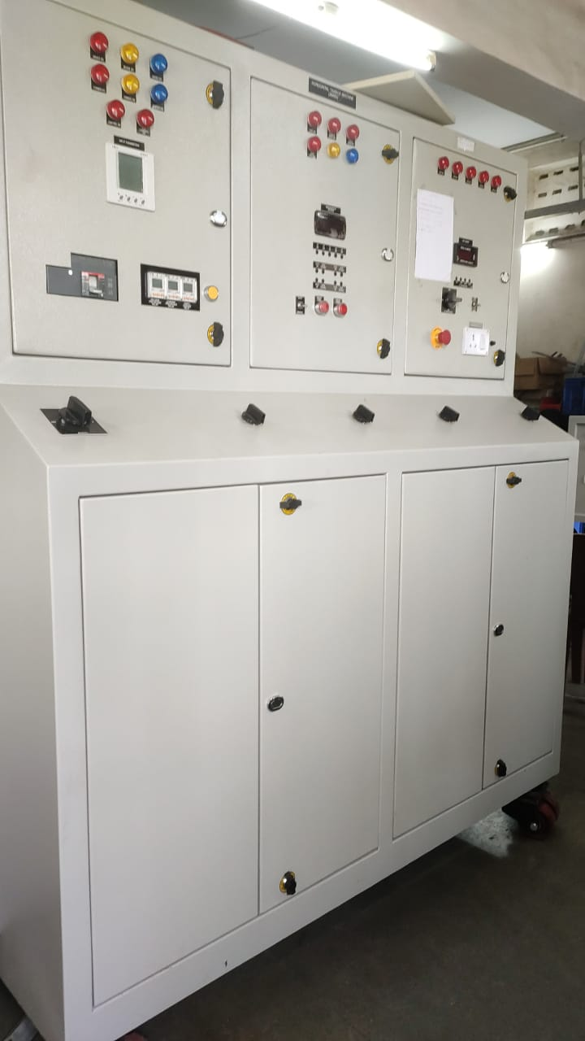 **@ Temperature rise kit (3000Amperes,12Volts current source)**

**Welcome to 3K Power Solutions**

**Consultants for High Voltage Solutions and Designers, Developers & Manufacturers of Custom Built Equipment.**

**3K POWER SOLUTIONS is an Expertise Company with pool of distinguished Senior Directors, Scientists and Officers who served CENTRAL POWER**

**RESEARCH INSTITUTE, BANGALORE, INDIA, for several decades. As flag bearers of the Institute for undertaking applied research in Electrical Power**

**Engineering beside providing field experience to ensure reliability in Power System and Innovate & Develop New products to Indian Power Sector**.

**To Know More About Us**

 **Equipment for Testing & Measurements**

**Testing & Certification**

**Customized Design & Development**

**Quality Accreditations**

**Research & Development**

**Consultancy for various Field Services**

#### 3k Power Solutions

* 3K Power Solutions provides general electrical construction services for mission critical

and other environments, from healthcare to government institutions, commercial

projects to industrial properties.

* Mission critical facilities present unique building challenges for Electrical contractors,

as operations simply cannot be disrupted at any time. Able to deftly navigate these

Environments, 3K Power Solutions’ expertise and manpower also enable us to work

With-in the often aggressive project schedules that these types of projects demand.

We recognize the importance of these facilities to the people they serve.

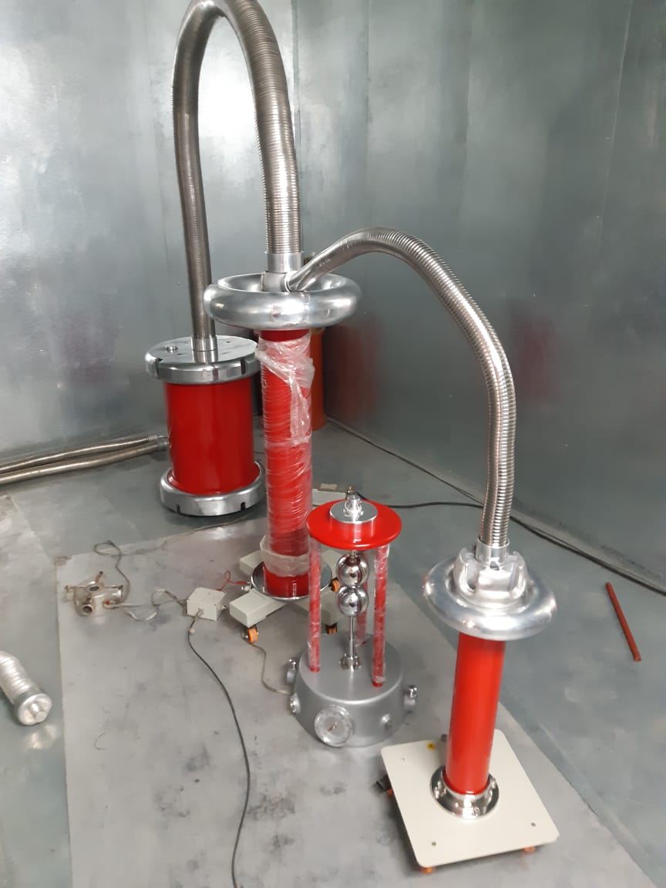

**OUR PRODUCTS**

**Products and Services**

**Services offered**

* AC Electric and magnetic field measurement under AC Transmission lines and Substations.
* DC Electric field and Ionic Current  measurement under DC Transmission lines and Substations.
* Consultancy work and RCA study on Renewable energy system (Wind and Solar system).
* RCA of Equipment and Systems up to 765kV.
* RCA of Solar system connected with HV cables.
* Diagnostic/Condition monitoring of substation and generating station Equipment.
* Power quality study on Non-linear load and Harmonic measurement/Analysis.
* Lesioning work for carrying out Type test of polymeric Insulators up to 765kV.

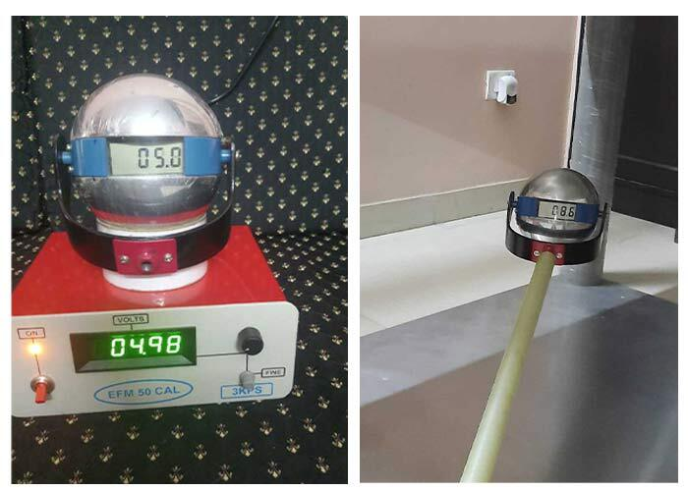

* Calculation of electric & magnetic field on double voltage double circuit lines using 3D Colum software.
* EFM calculation using 3D Colum software
* Pollution severity measurement at site.
* RTV, HVIC coating Insulators, Reactors & Bushings.
* Grounding system study.
* Services to Customized equipment like impulse voltage and current generators.
* Leakage current measurement of Lightning Arrester and its study.
* Failure analysis of HV and EHV equipment.

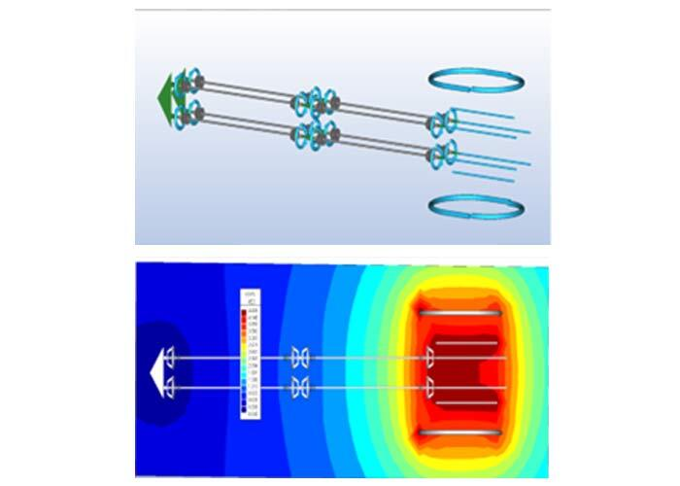

#### Portfolio of design & development of custom-built test equipment

@ Test Setup for conducting steep front wave test on polymeric insulator with a steepness of ≥ 1000kV/µS and ≥ 2500kV/µS

on porcelain Insulator

@ Design and Development of HTLS test setup, for conducting tests on HTLS conductor at room and elevated temperature

@ Impulse Voltage generator up to 1200kV and Impulse Current Generators up to 100 kA, 150kJ.

@ Partial Discharge measurement setup up to 300kV, including PD free AC power frequency source and faraday cage

@ Acceptance test facility for Distribution class Arrester of class1, up to 36kV.

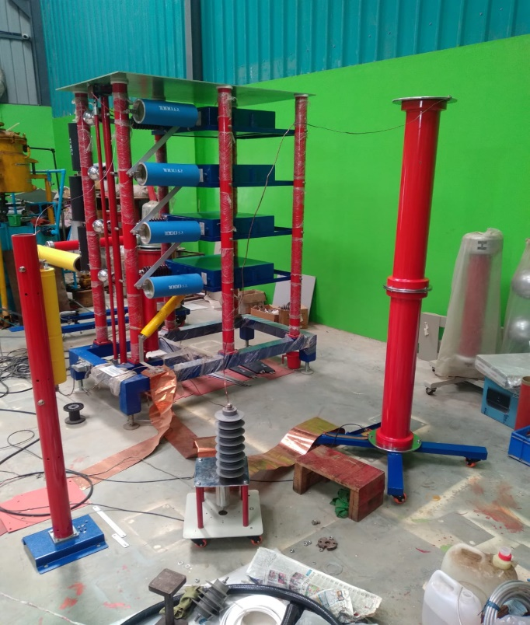 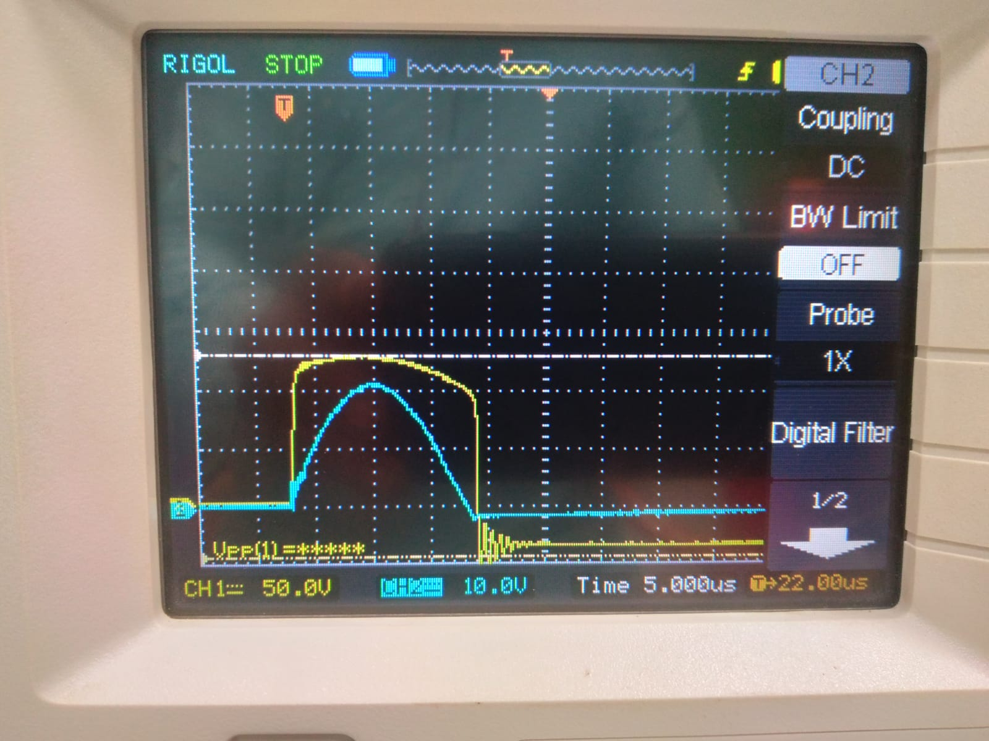

@ Different rating of customized AC/DC power supplies.

@ Combination wave generator 12kV, 6kA for testing RCCB, Energy Meter etc.

@ Current Source and current feeder pillar unit as per customer requirement

@ LT Panel design and validation as per National and International standard.

@ 20kV, 50Joulse, Impulse Voltage Generator for testing low capacitance loads.

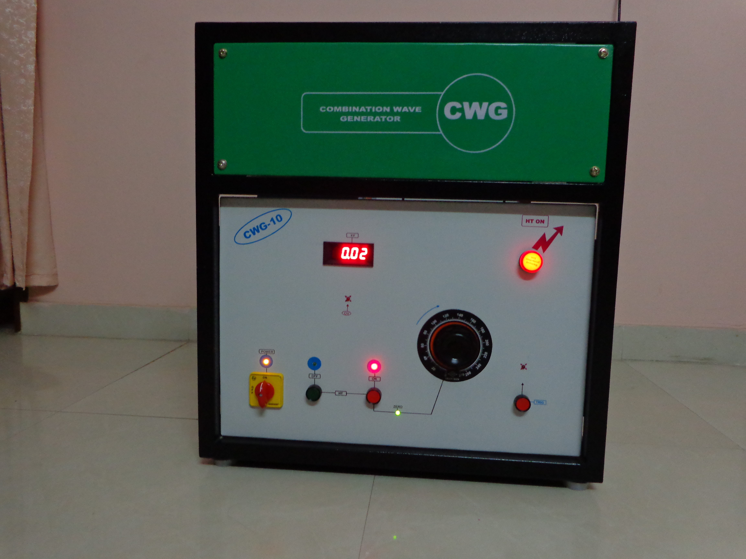 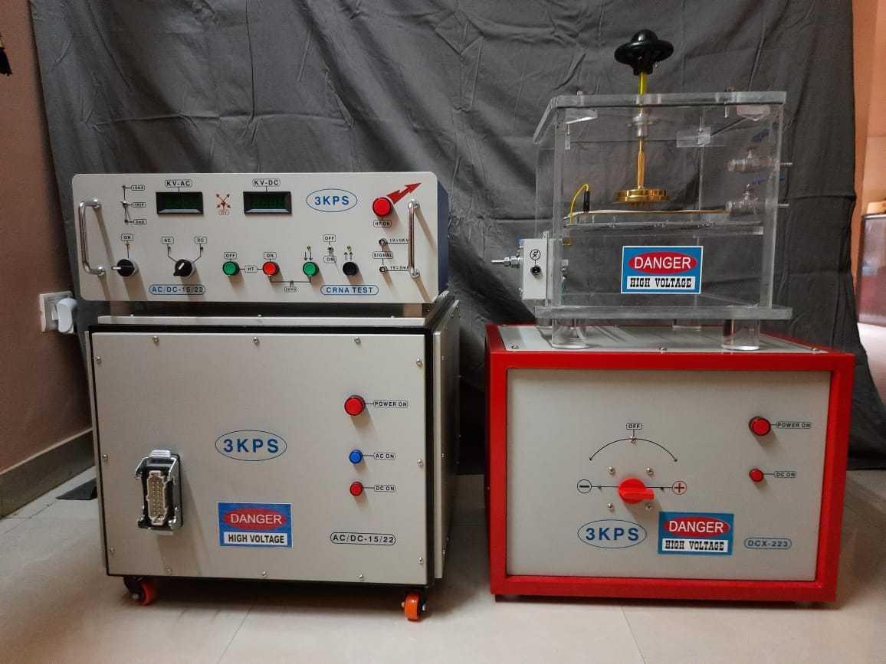

**TO KNOW MORE ABOUT US**

**WHO WE ARE ?**

* **Mr. K Karunakara, Sr. Consultant, Former Joint Director**, CPRI, has mnore than three and half decades rich experience in High Voltage field, Field Testing Services and Third-party Inspection. He has rich knowledge in finding RCA of the equipment and system up to 765kV. Also, has experience in design & development of custom-built equipment, repair and maintenance of equipment like 3 million volts, 150kJ Impulse voltage and 100kV, 150kJ, Current Generator from M/s Heafley, Switzerland and 1800kV, 1Amps, Power Frequency Transformer from High Volt, Germany.
* **Mr. P V Vasudevan Nambudiri, Sr. Consultant, Former Additional Director,** CPRI, has more than four-decade rich experience in design, development of high voltage test and measuring equipment. Also has experience in design, development & servicing of custom-built equipment.
* **Mr. Chandrashekar Keri, Sr. Consultant, Former Scientific officer,** CPRI, has more than three-decade rich experience in Diagnostic/Condition Monitoring of HV/EHV equipment. He also has experience in RLA study, Life Extension and RM&U studies.
* **Mr. B Gunasekaran, Sr. Consultant, former Additional Director,** CPRI, has more than four-decade experience in calculation of electric and magnetic field under the transmission line and EFM calculation using 3D Colum software
* **Dr. S Vynatheya, Sr. Consultant, Former Joint Director,**CPRI,  has three and half decades rich knowledge in material characterisation of engineering materials using sophisticated instruments. His field of intrest are failure analysis of engineering component, product development, RLA study on thermal/hydro power station components.

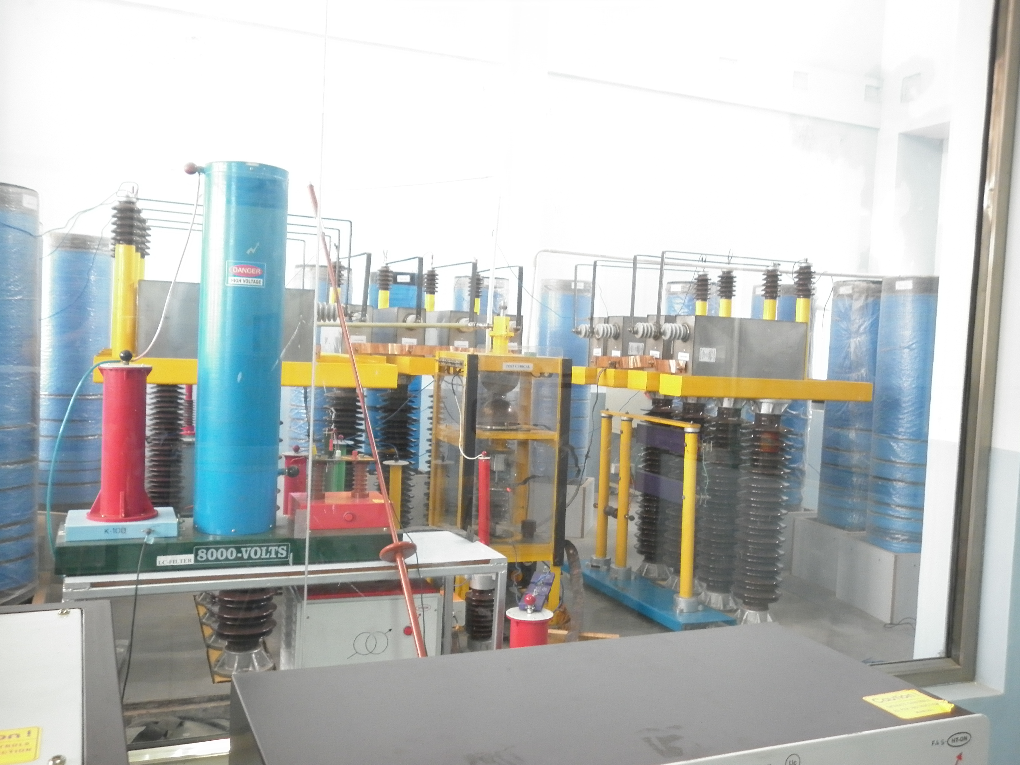

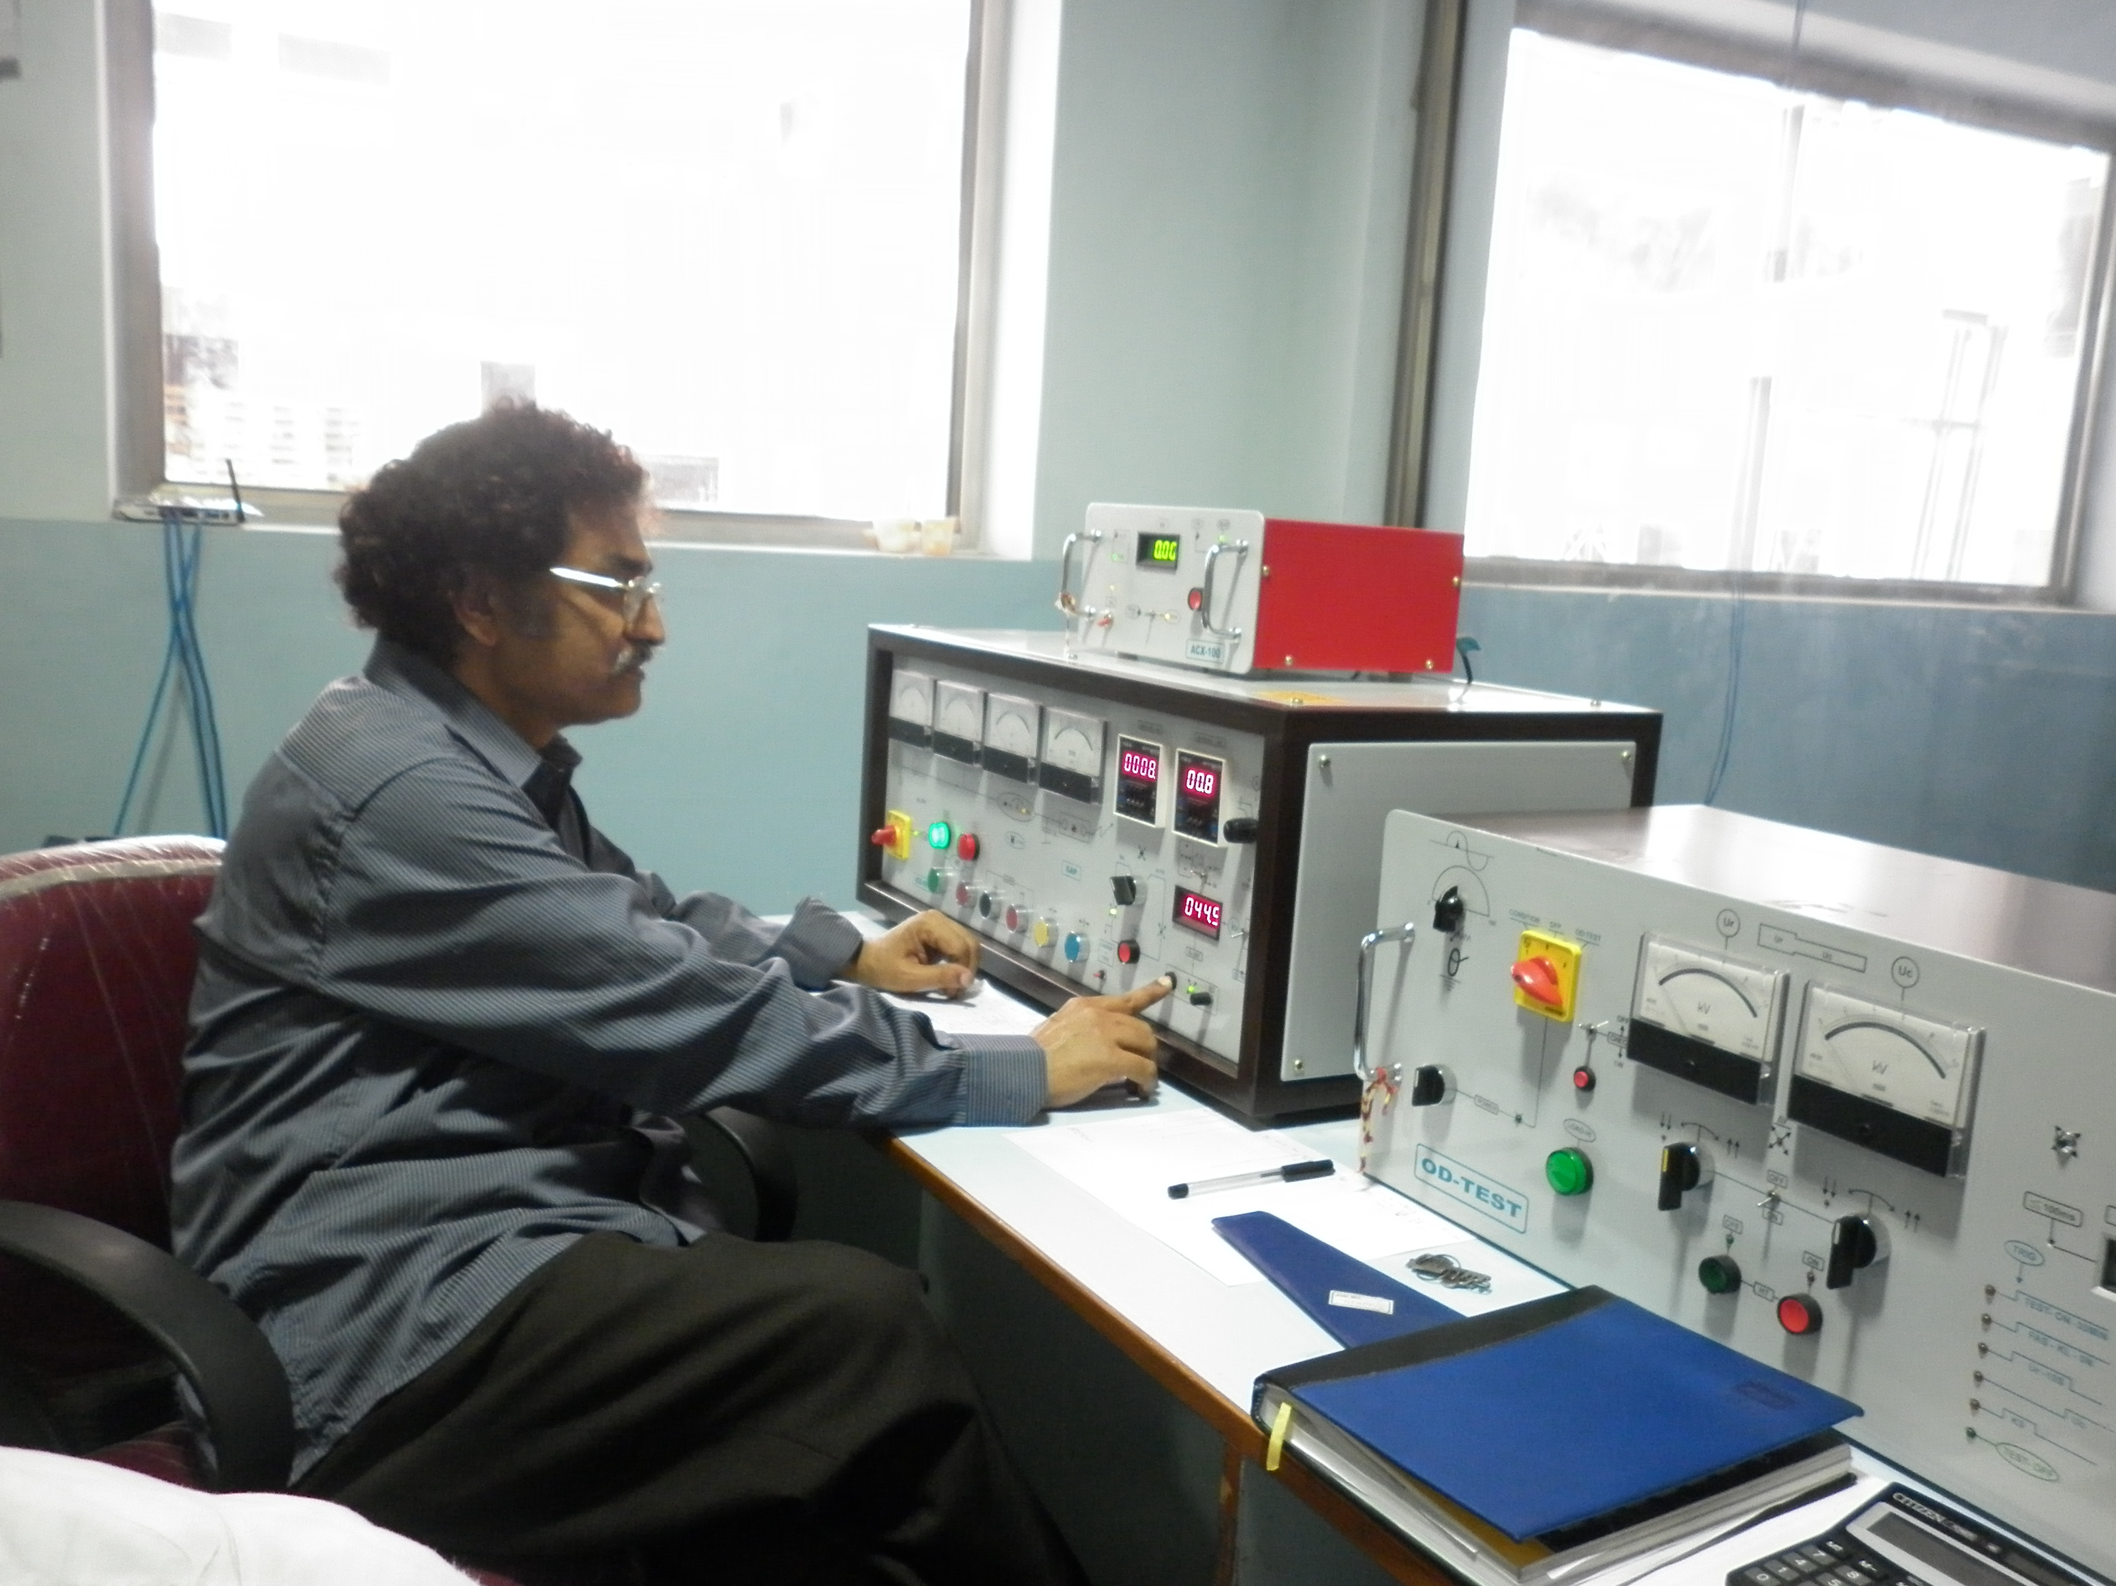

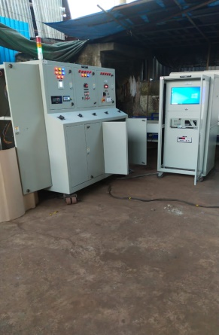 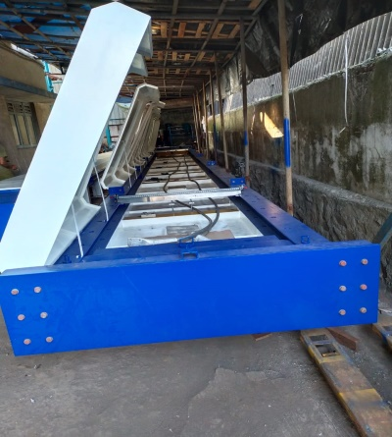 HTLS Test System consists of 100KN, 300KN UTS system and sheave cart system to perform

Creep test, Stress-strain test, Heat cycle test, UTS test, linearity of expansion test and sheave

test at ambient and elevated temperature.

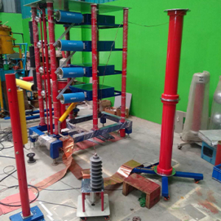 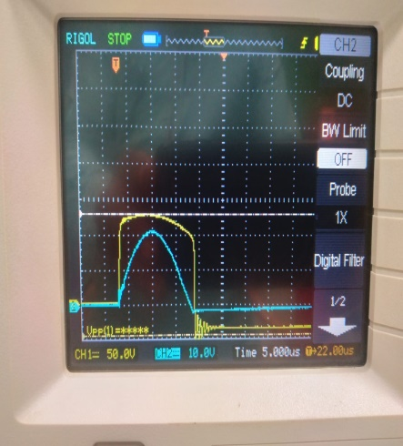 Impulse Voltage Generator up to 1400 KV 140 Kilo Joules for Testing Switchgears, Power

Transformers, etc and Impulse Current generator for testing Surge Arrester at  nominal discharge

current up to 10 Kilo Joules & 72 KV

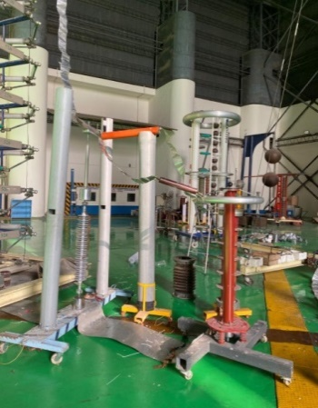 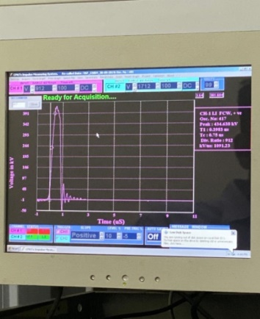

**STEEP FRONT TEST SET UP FOR COMPOSITE INSULATORS WITH AN STEEPNESS OF >1000Kv/µS**

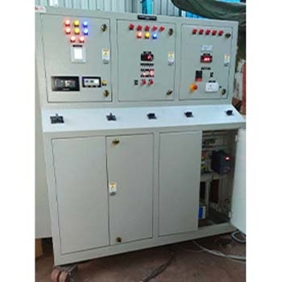Temperature Rise Kit to perform Temperature rise test on Different equipment like LT Panel, Tap Changers

and Switchgears

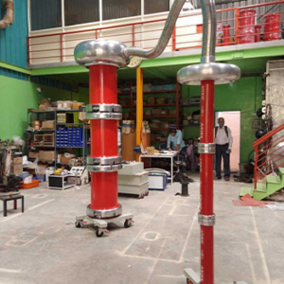

Power Frequency Source up to 300 KV 300KVA to test all Electrical Equipment including Cables

#### Our Success Stories

* HTLS Test System for IAC ELECTRICALS, Kolkata
* Calculation and Measurement of AC Electric and Magnetic field under AC Transmission line for CEA through KPTCL, Karnataka, India.
* Design Development & Supply of Short Time High Current Source for Indian Institute of Science, Bangalore, Karnataka, India
* Design Development & Supply of HV AC / DC Source for creation of Corona discharges, for Central Power Research Institute, Bangalore, Karnataka, India
* Design, Development and Supply of HV AC/DC variable stress test setup for Central Power Research Institute, Bangalore, Karnataka, India.
* Root Cause Analysis of Fire & Failure of 33KV Feeder Conductor to SGS INDIA for Siemens GAMESA Windfarm in Andhra Pradesh, India.
* EFM Calculations for 765 KV Composite Insulators for POWERGRID through GK XIANGHE Electricals Pvt Ltd, India
* EFM Calculations for 220 KV Composite Insulators to SHREERADHE Industries for ADANI POWER, India.
* Root Cause Analysis for Failure of Catenary Wire & Degradation of Insulation Coating to INDIAN RAILWAYS through Oriental Enterprises, Mumbai, Maharashtra, India.
* Design, Development & Supply of 3000Amperes, 12Volts, Temperature Rise Test Kit for ALWAYE LOAD SELECTORS, Bangalore, Karnataka, India.
* Measurement of AC Electric and Magnetic field under AC Transmission lines to evaluate the induction effects and determining the clearances for GE-WEBTEC Bangalore, Karnataka, India.

**GALLARY**

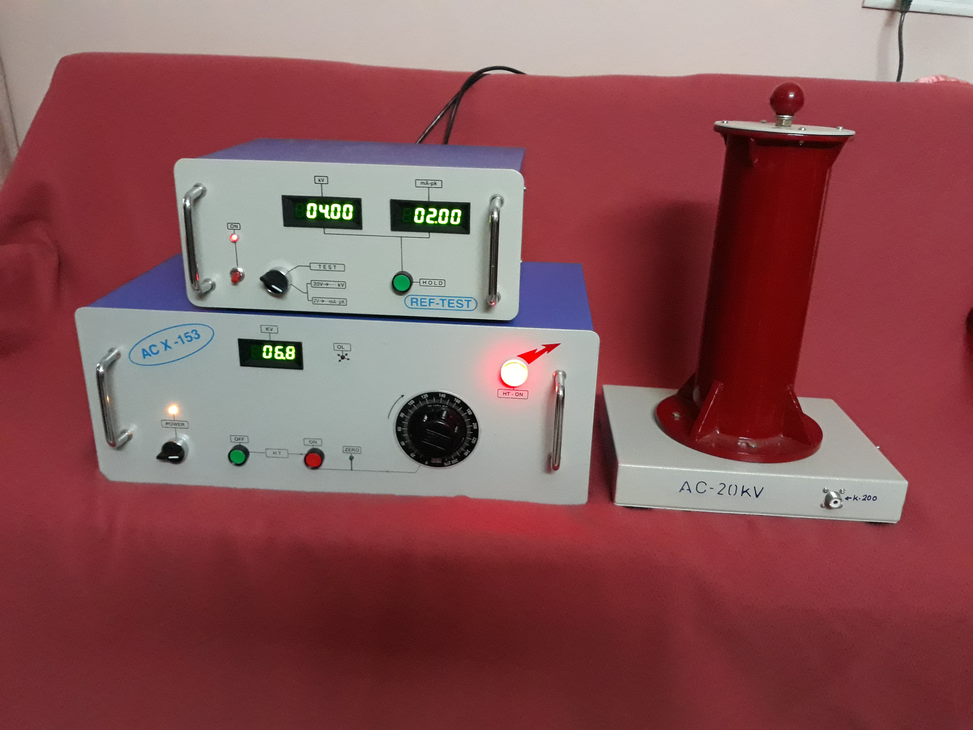 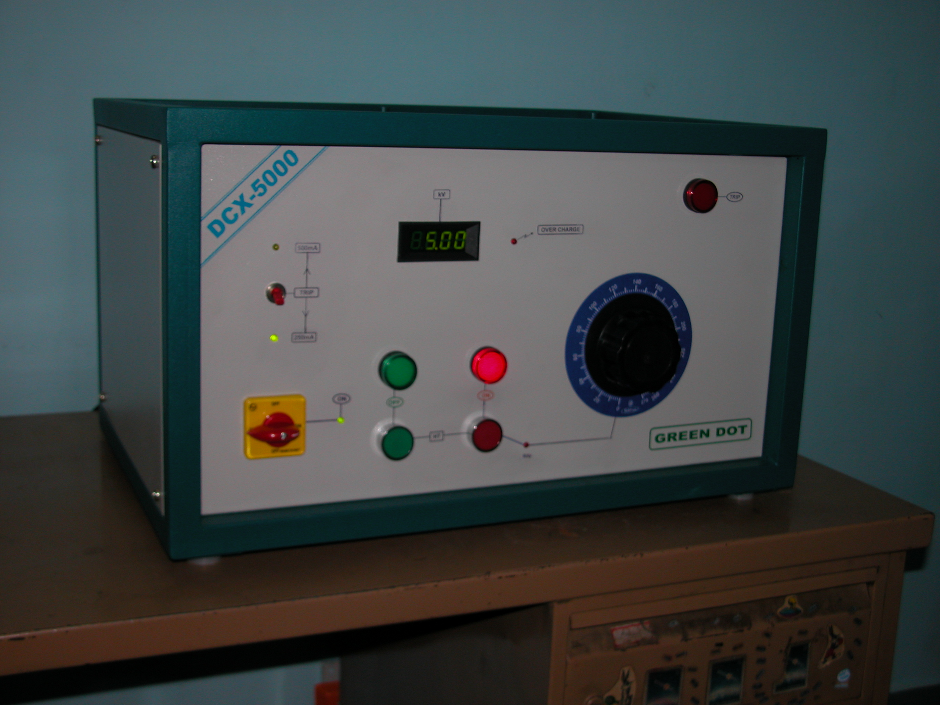 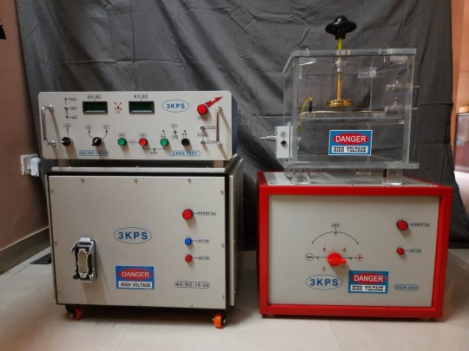 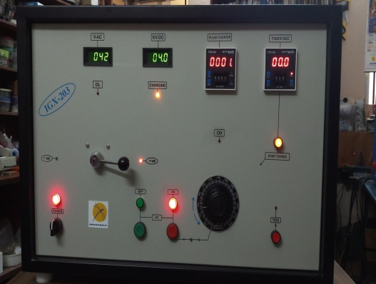

**Measurement of Resistive component of Zno block HVAC & HVDC Corona power supply 20kV, 50kJ Impulse generator**

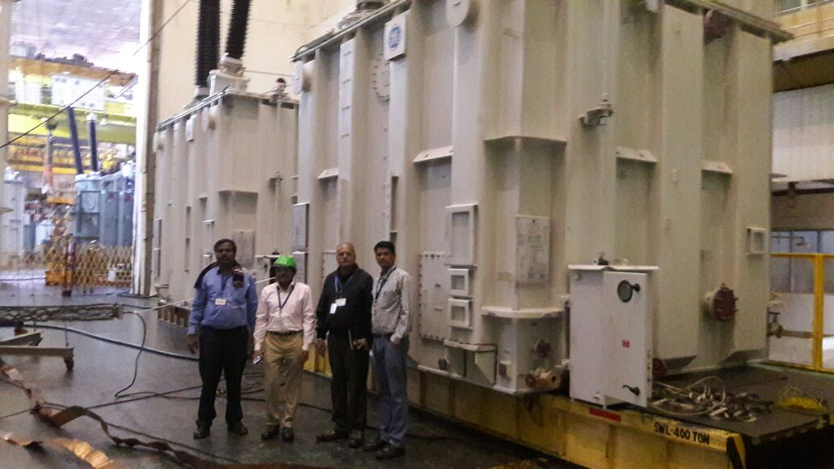 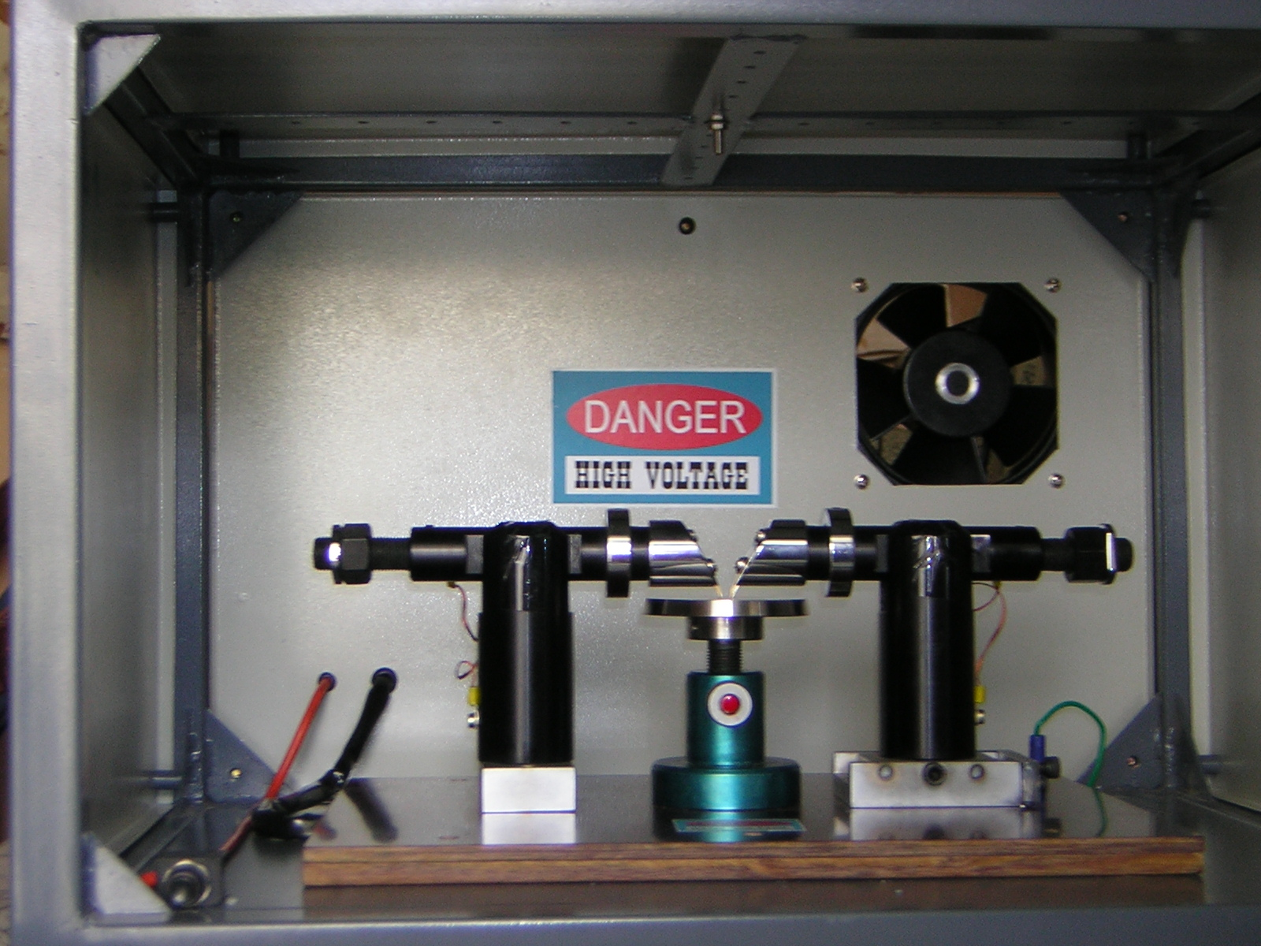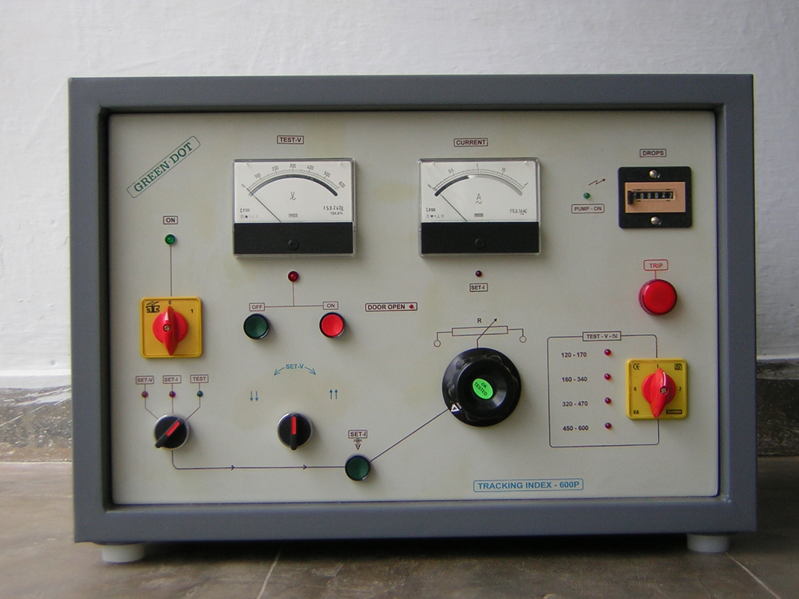

**Temperature rise test of Transformer at customer place Isolated tracking system**

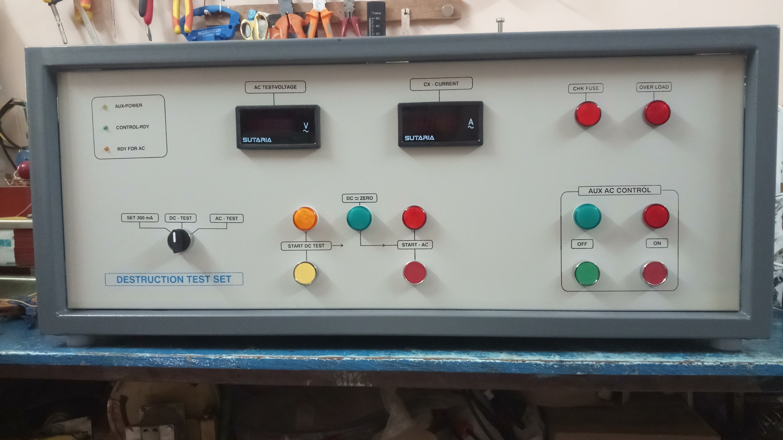 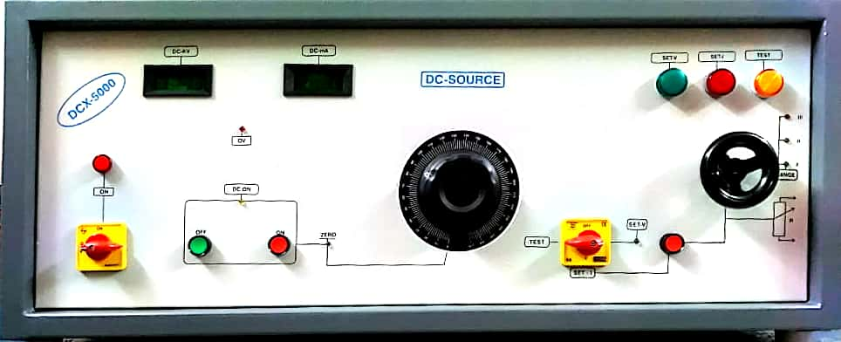 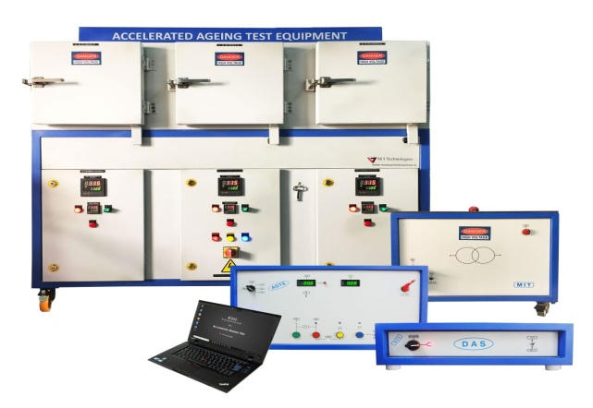

**Destructive test set up with 5kV 1Amperes power supply Accecelarated Aging setup of Zno Block**

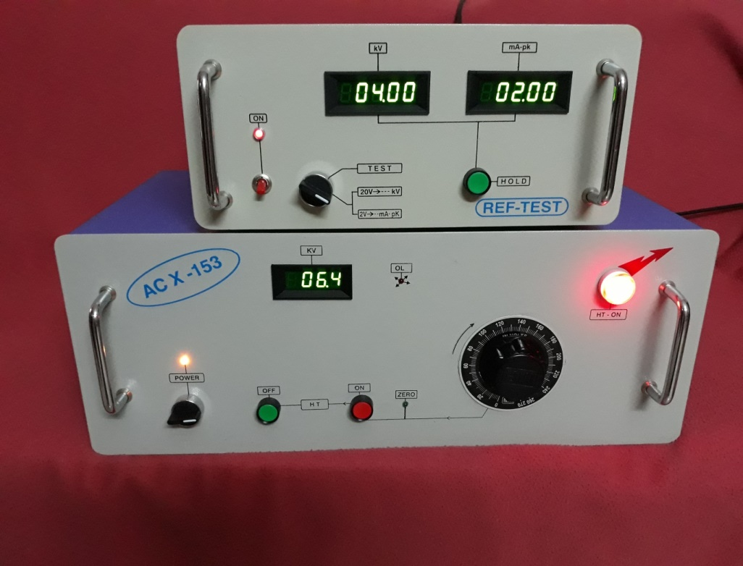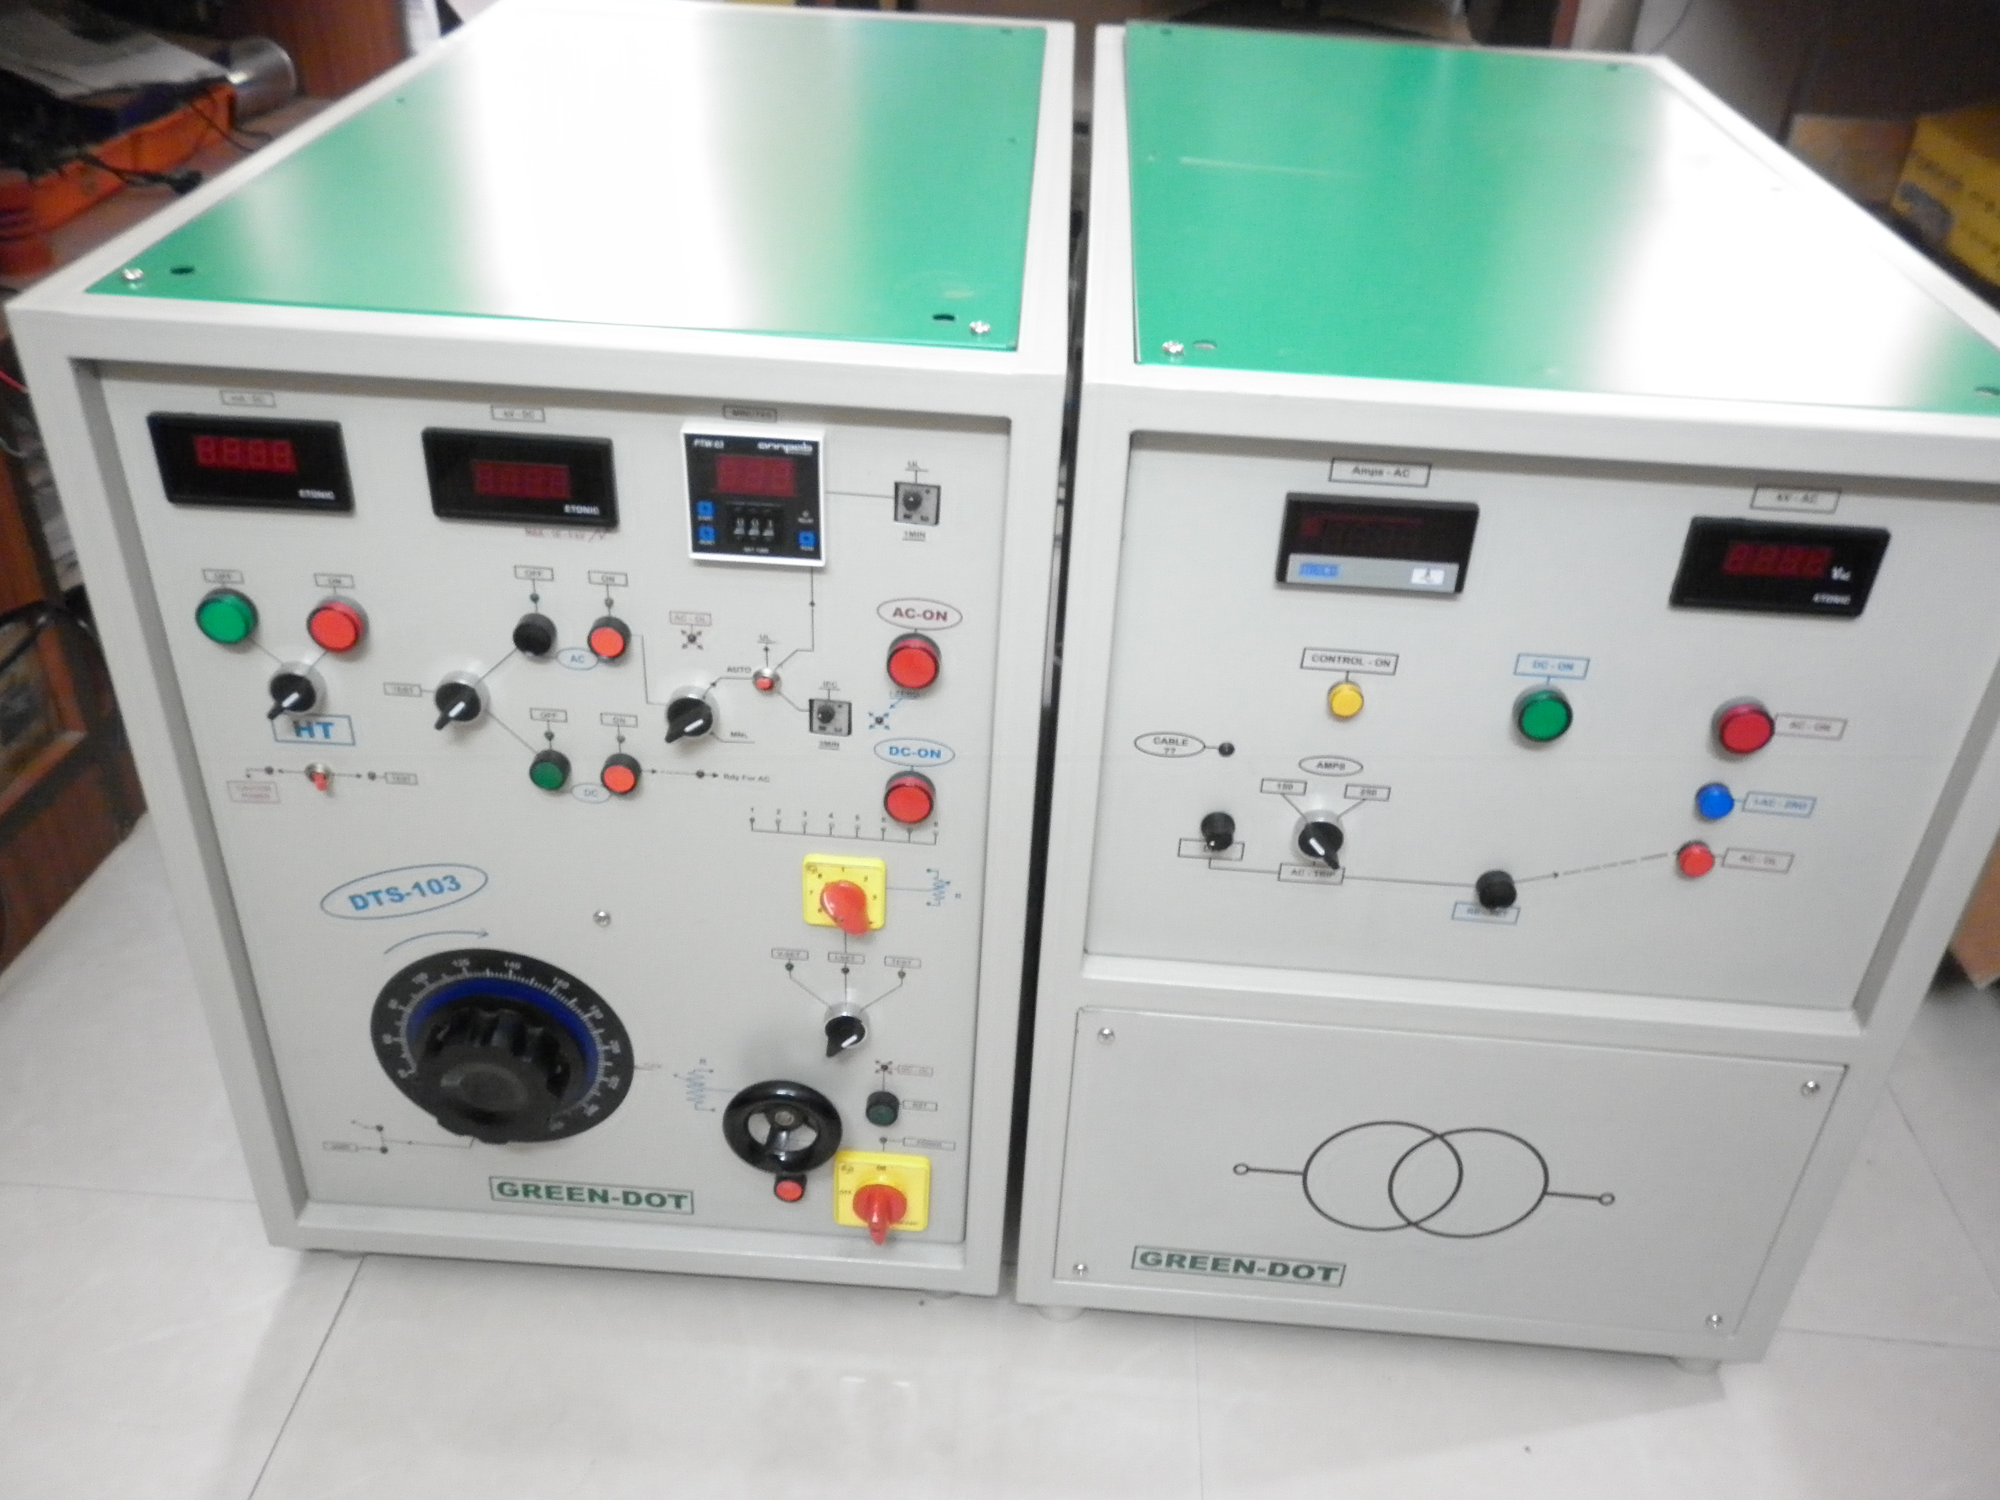

**Zno Referance test set up with AC source Destructive test set up for Capacitors**

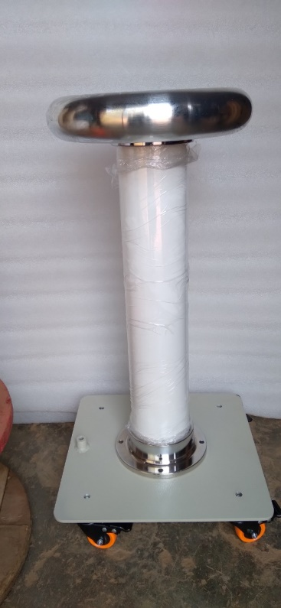 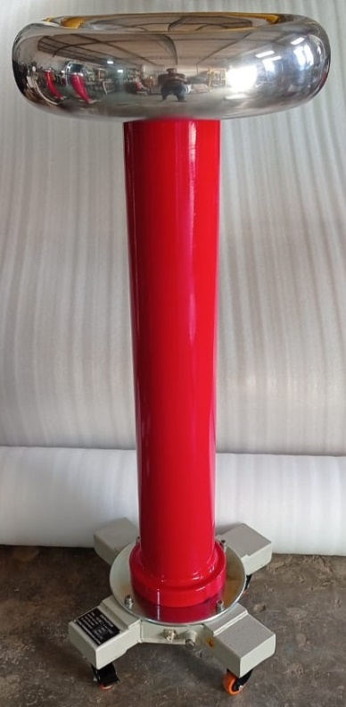 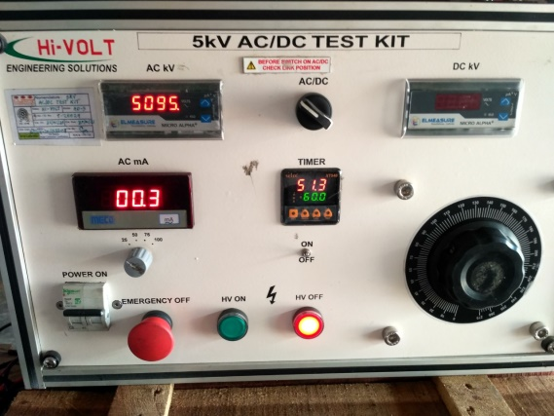 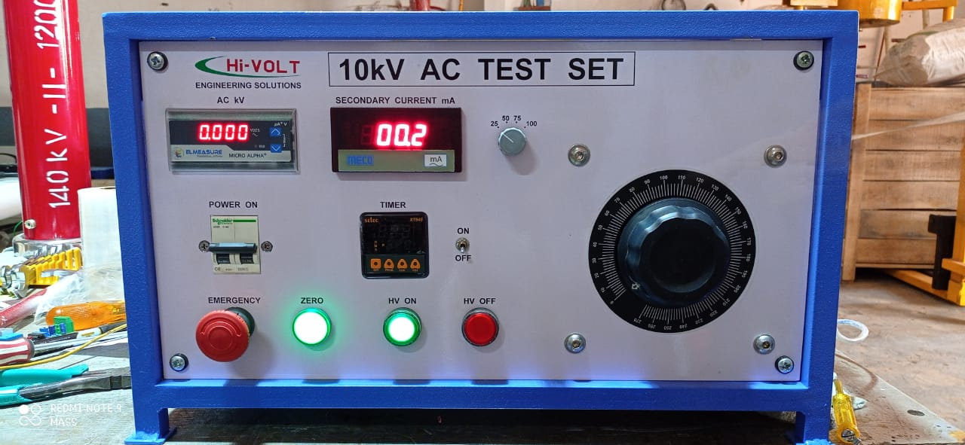

**60kV Capacitive 100kV Capacitive 5kV AC/DC Test Kit 10kV AC Test Kit**

**Voltage Divider Voltage Divider**



**Partial Discharge set up**